SIMATS ENGINEERING
ASSESSMENT TOOL 3

COURSE NAME: Artificial Intelligence COURSE CODE: CSA17

COURSE OUTCOME COVERED

CO2: Experiment search and game-solving techniques such as Greedy Search, A*, CSP, Minimax, and Alpha-Beta pruning with heuristic functions for solving complex AI problems efficiently. (BL3)

Assessment Tool Weightage: 40%

Duration: 1 Hour
QUESTIONS: 3 Total Marks:30

Annexure A

Dry Run Evaluation

Code of Conduct:

I SOUNDARIYA M ( 192524342) (Name / Reg No) certify that this submission is my original work and that I have adhered to the guidelines specified for this assessment.
I understand that any violation of academic integrity rules will result in disciplinary action.

Signature of the student:

SOUNDARIYA M

Annexure A

Dry Run Evaluation
1. Question 1 – Breadth-First Search (BFS)
Consider the following graph: A
/ \
B C
/ \ / \
D E F G
Task: Starting from node A, perform a Breadth-First Search (BFS). Complete the following table.
Iteration | Queue | Visited Node
1
2
3
4
5
6
7
Questions:
- Write the BFS traversal order.
- Show the queue contents after each iteration.

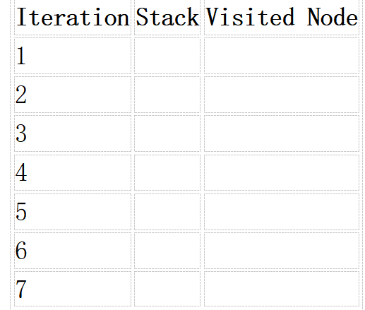
2. Depth-First Search (DFS) Using the same graph,
A
/ \
B C
/ \ / \
D E F G
Perform Depth-First Search (DFS) starting from A.
Complete the table.
- Initial State :
1 3 6
5 0 2
4 7 8

Goal State :
1 2 3
4 5 6
7 8 0

Task
Trace Breadth-First Search (BFS) until the goal state is reached.
Fill in the table.
Iteration | Current State | Queue Before Expansion | Queue After Expansion
1
2
3
4
5

Questions
- Which node is expanded in each iteration?
- How many states are generated in total?
- Write the complete solution path from the initial state to the goal state.
- Why does BFS always find the shortest solution in an unweighted 8-puzzle problem?

RUBRICS FOR CALCULATION

Criteria | Weightage (%) | Level 4 – Exemplary (4) | Level 3 – Proficient (3) | Level 2 – Developing (2) | Level 1 – Beginning (1)
Understanding of Search Problem | 20 | Clearly understands the search problem, initial state, goal state, and search strategy. | Understands the problem with minor misunderstandings. | Demonstrates partial understanding of the search problem. | Shows little or no understanding of the search problem.
State Expansion and Dry Run Execution | 30 | Correctly traces every iteration, expands nodes accurately, and maintains the Queue/Stack/Priority Queue without errors. | Performs most iterations correctly with minor mistakes in state expansion or data structure updates. | Performs only some iterations correctly; several errors in tracing or node expansion. | Unable to correctly perform the dry run or expand states.
Application of Search Algorithm | 20 | Applies the selected algorithm (BFS/DFS/UCS) correctly, following all algorithmic rules. | Applies the algorithm correctly with a few procedural errors. | Applies only basic algorithm steps with noticeable mistakes. | Fails to apply the correct search algorithm.
Accuracy of Solution Path | 20 | Identifies the correct traversal order/solution path and goal state with proper justification. | Solution path is mostly correct with minor errors. | Partially correct solution path; goal may not be reached correctly. | Incorrect or incomplete solution path.
Presentation and Logical Reasoning | 10 | Queue/Stack/Priority Queue updates, state diagrams, and explanations are neat, organized, and logically presented. | Presentation is clear with minor organizational issues. | Limited explanation and organization; reasoning is partially clear. | Poor presentation with unclear or missing reasoning.

- Given graph:
A
/ \
B C
/ \ / \
D E F G

CODE:

from collections import deque

graph = {
'A': ['B', 'C'],
'B': ['D', 'E'],
'C': ['F', 'G'],
'D': [],
'E': [],
'F': [],
'G': []
}

def bfs(start):
queue = deque([start])
visited = []

while queue:
node = queue.popleft()

if node not in visited:
visited.append(node)
queue.extend(graph[node])

return visited

print("BFS Traversal:", bfs('A'))

OUTPUT:

BFS Traversal Order
A → B → C → D → E → F → G
Queue Dry Run

Iteration | Queue Before | Visited Node | Queue After
1 | A | A | B, C
2 | B, C | B | C, D, E
3 | C, D, E | C | D, E, F, G
4 | D, E, F, G | D | E, F, G
5 | E, F, G | E | F, G
6 | F, G | F | G
7 | G | G | Empty

- DEPTH-FIRST SEARCH(DFS):

DFS Traversal Order
A → B → D → E → C → F → G

DFS Dry Run
Step | Current Node | Visited
1 | A | A
2 | B | A, B
3 | D | A, B, D
4 | E | A, B, D, E
5 | C | A, B, D, E, C
6 | F | A, B, D, E, C, F
7 | G | A, B, D, E, C, F, G

CODE:

graph = {
'A': ['B', 'C'],
'B': ['D', 'E'],
'C': ['F', 'G'],
'D': [],
'E': [],
'F': [],
'G': []
}

def dfs(node, visited):
visited.append(node)

for next_node in graph[node]:
if next_node not in visited:
dfs(next_node, visited)

visited = []

dfs('A', visited)

print("DFS Traversal:", visited)

OUTPUT:

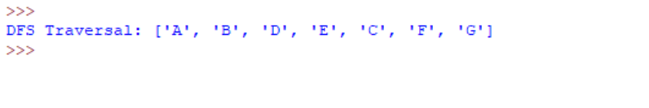

- 8 PUZZLE BFS

Initial state:
1 3 6
5 0 2
4 7 8

Goal state:
1 2 3
4 5 6
7 8 0

Solution path:

1 3 6 1 3 6 1 3 0
5 0 2 → 5 2 0 → 5 2 6
4 7 8 4 7 8 4 7 8

→ 1 0 3 → 1 2 3 → 1 2 3
5 2 6 5 0 6 0 5 6
4 7 8 4 7 8 4 7 8

→ 1 2 3 → 1 2 3 → 1 2 3
4 5 6 4 5 6 4 5 6
0 7 8 7 0 8 7 8 0

Explanation:

- Expanded states: Initial state → intermediate states → Goal state.
- States generated: Depends on the order used to generate moves.
- Solution length: 8 moves.
- BFS finds the shortest solution because it explores states level by level, so the first goal reached has the minimum number of moves.

CODE:

from collections import deque

start = (1, 3, 6,
5, 0, 2,
4, 7, 8)

goal = (1, 2, 3,
4, 5, 6,
7, 8, 0)

def moves(state):
result = []
zero = state.index(0)
row, col = divmod(zero, 3)

directions = [(-1,0), (1,0), (0,-1), (0,1)]

for dr, dc in directions:
r, c = row + dr, col + dc

if 0 <= r < 3 and 0 <= c < 3:
pos = r * 3 + c
new_state = list(state)

new_state[zero], new_state[pos] = \
new_state[pos], new_state[zero]

result.append(tuple(new_state))

return result

def bfs(start, goal):
queue = deque([(start, [start])])
visited = {start}

while queue:
state, path = queue.popleft()

if state == goal:
return path

for new_state in moves(state):
if new_state not in visited:
visited.add(new_state)
queue.append((new_state, path + [new_state]))

path = bfs(start, goal)

print("Solution Path:")

for state in path:
print()
print(state[0:3])
print(state[3:6])
print(state[6:9])

OUTPUT:

